

Brown Fox, PLLC

Commercial insurance proposal

Presented by: Kyle L Cardwell  
kcardwell@swinglecollins.com

(972) 387-6739

13760 Noel Road, Suite 600

Dallas, TX 75240

Table of Contents

Why Choose Swingle Collins? 3

Your Trusted & Knowledgeable Advisors 4

Thorough & Accurate Coverage 5

Property 6

General Liability 8

Commercial Auto 9

Crime 10

Professional Liability 12

Additional Coverage to Consider 13

Premium Summary 14

Marketing Summary 15

We’re Here for You 24/7 17

Why Choose Swingle Collins?

As one of the largest privately-owned insurance agencies in Texas, Swingle Collins & Associates is able to provide solutions for even the most unique and complex risks. Our status as an independent firm allows us to offer the type of tailored service and coverage options that our clients both expect and deserve.

Because of our growth, success and level of service, leading carriers have awarded us top-tier access, which directly benefits our clientele with a broader range of choices and services. By adopting a consultative approach and staying at the forefront of emerging trends, we’re able to deliver options that are selected specifically to ensure that your business, assets, family, and employees have the level of coverage they need.

Our elite team of risk advisors is considered best-in-class by industry peers and clients alike. We’ve been named a Top 100 Independent Property/Casualty Agency by *Insurance Journal* and rated among the “Best Places to Work” by *Insurance Journal* and the *Dallas Business Journal*.

In everything we do, we strive to be an extension of your company and family wealth management team, providing you with the peace of mind that your assets are properly protected — and that your needs will always come first.

Your Trusted & Knowledgeable Advisors

|  |  |  |
| --- | --- | --- |
|  |  | Personal Risk Advisor |
|  |  | *Your coverage expert and partner.* |
|  |  | **Kyle L Cardwell CLCS, MSM** |
|  |  | (972) 387-6739 |
|  |  | [kcardwell@swinglecollins.com](mailto:kcardwell@swinglecollins.com) |
|  |  |  |

|  |  |  |
| --- | --- | --- |
|  |  | Account Manager |
|  |  | *Provides support for claims, billing, and coverage questions.* |
|  |  | **Erin Grady MBA, CISR** |
|  |  | (972) 715-8775 |
|  |  | [egrady@swinglecollins.com](mailto:egrady@swinglecollins.com) |
|  |  |  |

|  |  |  |
| --- | --- | --- |
|  |  | Assistant Account Manager |
|  |  | *Supports the team and will often contact you to follow up on  outstanding items, billing, and renewals.* |
|  |  | **Jessica Staggs** |
|  |  | (972) 715-8779 |
|  |  | [jstaggs@swinglecollins.com](mailto:jstaggs@swinglecollins.com) |
|  |  |  |

|  |  |  |
| --- | --- | --- |
|  |  | Certificate and Evidence of  Property REquests |
|  |  |  |
|  |  | **Services Department** |
|  |  | [services@swinglecollins.com](mailto:services@swinglecollins.com) |
|  |  |  |

Thorough & Accurate Coverage

Our goal is to make sure that you always have adequate coverage in place for your family, your assets, and your business. That’s why it’s important to contact us when there are any changes that may have a bearing on your insurance program. Your insurers evaluate and accept risks on the basis of the information you’ve given; any outdated information could lead to complications in the event of a loss.

* **These changes may include, but are not limited to:**
* Change of mailing and/or billing address.
* Changes in your personnel who are responsible for insurance decisions.
* Personnel traveling overseas, on temporary assignment overseas, or working on military bases.
* Acquisitions, creation of new companies or subsidiaries, and/or mergers in which you are involved, or that change the legal corporate structure in any way.
* Purchase, construction, or occupancy of new premises, either foreign or domestic. This includes alteration, vacating the premises, temporary inoccupancy, or extension or demolition of existing premises.
* Increase in the value of a building or business personal property, for both scheduled and unnamed locations.
* Transfer of business personal property, inventory, or stock to a new or temporary location.
* Any addition of new locations, equipment, or vehicles, whether they are hired, leased, or borrowed.
* Changes in processes, occupancy, products, or business operations.
* Addition, alteration or temporary disconnection of fire or burglary protection systems.
* Use of aircraft or watercraft, whether or not you own them.
* Major changes in the value or nature of goods being shipped.
* Employment of personnel in states in which you were previously not doing business.
* Election or appointment of a new CEO or COO, or any change in control of either the company’s Board of Directors or stock ownership.
* Changes in ERISA Plan Assets.
* Addition of new drivers for the company.
* Insurance requirements for a lease or business contract that require additions or changes to your existing coverage.

Property

|  |  |
| --- | --- |
| **Issuing Company** | **Hanover Insurance Company** |
| **Policy Number** | **OHD-A960711-09** |
| **Policy Term** | **8/1/2024 to 8/1/2025** |

Named Insureds

| Insured | Interest |
| --- | --- |
| Brown Fox, PLLC | First Named Insured |

0

Coverages

| Loc | Bldg | Subject | Amount | Val | Coinsurance | Cause of Loss | Deductible |
| --- | --- | --- | --- | --- | --- | --- | --- |
| **1** | **1** | **8111 Preston Road, Ste 300 • Dallas, TX 75225** | | | | | |
|  |  | Business Personal Property | $130,977 | Replacement Cost |  | SPCSpecial | $1,000111 |
| **2** | **1** | **5550 Granite Parkway, Suite 175 • Plano, TX 75024** | | | | | |
|  |  | Business Personal Property | $249,480 | Replacement Cost |  | SPCSpecial | $1,000211 |

Additional Interests

| Interest | Name and Address |
| --- | --- |
| Loss Payee  Loc 1, Bldg 1 | Veritex Community Bank Insurance Service Center PO Box 863329 Plano, TX 75086-3329 |

Endorsements

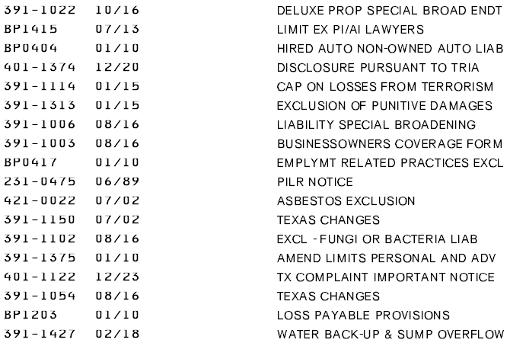

General Liability

|  |  |
| --- | --- |
| **Issuing Company** | **Hanover Lloyds Insurance Company** |
| **Policy Number** | **OHD-A960711-09** |
| **Policy Term** | **8/1/2024 to 8/1/2025** |

Named Insureds

| Insured | Interest |
| --- | --- |
| Brown Fox, PLLC | First Named Insured |

Coverages

|  |  |
| --- | --- |
| Description | Limit |
| General Aggregate | $2,000,000 |
| Products / Completed Operations Aggregate | $2,000,000 |
| Each Occurrence | $1,000,000 |
| Personal and Advertising Injury | $1,000,000 |
| Fire Damage (Any One Fire) | $300,000 |
| Medical Expense (Any One Person) | $5,000 |

Locations and Exposures

| Loc | | Bldg | Description | Exposure | Premium Basis | |
| --- | --- | --- | --- | --- | --- | --- |
| **1** | **1** | | **8111 Preston Road, Ste 300 • Dallas, Texas 75225** | | | |
|  | | | Lawyers Office | 4,210 | | Area |
| **2** | **1** | | **5550 Granite Parkway, Suite 175 • Plano, Texas 75024** | | | |
|  | | | Lawyers Office | 6,384 | | Area |

Commercial Auto

|  |  |
| --- | --- |
| **Issuing Company** | **Hanover Lloyds Insurance Company** |
| **Policy Number** | **OHD-A960711-09** |
| **Policy Term** | **8/1/2024 to 8/1/2025** |

Named Insureds

| Insured | Interest |
| --- | --- |
| Brown Fox, PLLC | First Named Insured |

Coverages

|  |  |  |
| --- | --- | --- |
| Description | Symbol | Limit |
| Combined Single Limit | 8, 9 | $1,000,000 |
| Hired / Borrowed Auto Liability | 8 | Included |
| Non-owned Auto Liability | 9 | Included |

|  |  |  |
| --- | --- | --- |
| *Symbol Definition | | |
| (1) Any Auto | (4) Owned Autos Other Than Private Passenger | (7) Autos Specified On Schedule |
| (2) All Owned Autos | (5) All Owned Autos Requiring No-Fault Coverage | (8) Hired Autos |
| (3) Owned Private Passenger Autos | (6) Owned Autos Subject To Compulsory U.M. Law | (9) Non-Owned Autos |

Crime

|  |  |
| --- | --- |
| **Issuing Company** | **Federal Insurance Company** |
| **Policy Number** | **J06277718** |
| **Policy Term** | **8/1/2024 to 8/1/2025** |

Named Insureds

| Insured | Interest |
| --- | --- |
| Brown Fox, PLLC | First Named Insured |

Coverages

| Loc | Bldg | Description | Limit | Deductible |
| --- | --- | --- | --- | --- |
| **1** | **1** | **8111 Preston Road, Ste 300 • Dallas, TX** | | |
|  |  | Employee Theft | $1,000,000 | $10,000 |
|  |  | Client Theft | $1,000,000 | $10,000 |
|  |  | ERISA Fraud or Dishonesty | $1,000,000 | None |
|  |  | Forgery or Alteration | $1,000,000 | $10,000 |
|  |  | Theft of Money and Securities - Inside Premises | $1,000,000 | $10,000 |
|  |  | Theft of Money and Securities - Outside Premises | $1,000,000 | $10,000 |
|  |  | Computer Fraud | $1,000,000 | $10,000 |
|  |  | Funds Transfer Fraud | $1,000,000 | $10,000 |
|  |  | Money Orders and Counterfeit Currency | $1,000,000 | $10,000 |
|  |  | Social Engineering Fraud | $50,000 | $10,000 |
|  |  |  |  |  |

Endorsements

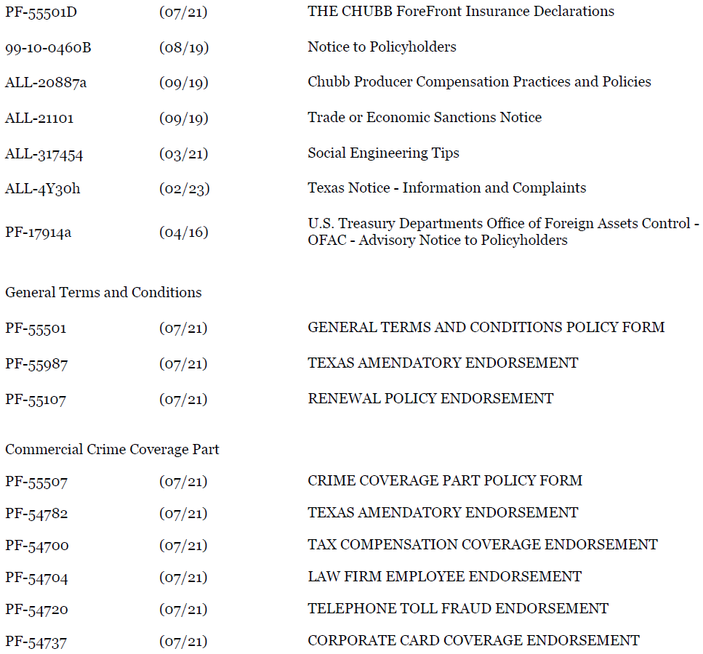

Professional Liability

|  |  |
| --- | --- |
| **Issuing Company** | **Berkley Insurance Company.** |
| **Policy Number** | **PENDING** |
| **Policy Term** | **8/1/2024 to 8/1/2025** |

Named Insureds

| Insured | Interest |
| --- | --- |
| Brown Fox PLLC | First Named Insured |

Coverages

| Description | Limit |
| --- | --- |
| Professional Liability (per Claim/Aggregate Limit)  Retention  Retroactive Date  Claims Made | $1,000,000  $15,000  8/1/2015 |

Endorsements

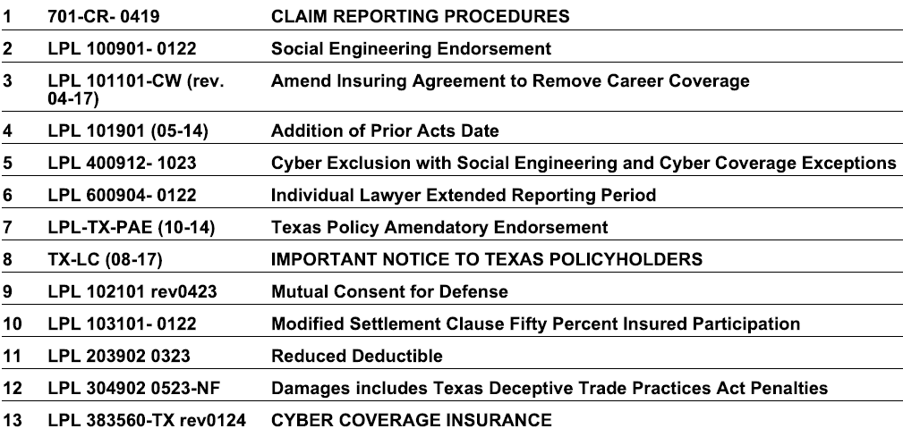

**OPTIONAL QUOTE**

$2,000,000 Per Claim/Aggregate Limit; $15,000 Retention $67,965.00

Additional Coverage to Consider

Below is a list of coverages for your consideration:

* Accident
* Bonds
* Builders Risk
* Business Income (Loss of Income and Extra Expense)
* Cargo
* Crime
* Cyber Liability
* Deductible Buy Back
* Dependent Property
* Directors & Officers Liability
* Earthquake
* Employed Lawyer
* Employee Benefits Liability
* Employment Practices Liability
* Fiduciary Liability
* Flood
* Foreign Liability or Travel Insurance
* Group Excess
* Higher Liability Limits
* Inland Marine
* Kidnap and Extortion
* Pollution Liability
* Professional Liability
* Trade Credit
* Transit
* Workplace Violence

Premium Summary

|  |  |  |
| --- | --- | --- |
| Coverage | Expiring Premium | Renewal Premium |
| **Property** | **$1,984** | **$2,265** |
| **General Liability** | **Included** | **Included** |
| **Business Auto** | **Included** | **Included** |
| **Crime** | **$2,585** | **$2,585** |
| **Professional Liability** | **$46,275** | **$53,123.00** |
| Number of Lawyers | 18 | 22 |
| Premium per Lawyers | $2,570 | $2,414 |
| **Grand Total** | **$50,844** | **$57,973** |

Payment Options

|  |  |  |  |
| --- | --- | --- | --- |
| Down Payment Amount | Check Payable to | # of Installments | Installment Fee |
| $2,265.00 | Hanover Insurance Group | 1 | N/A |

|  |  |  |  |
| --- | --- | --- | --- |
| Down Payment Amount | Check Payable to | # of Installments | Installment Fee |
| $2,585.00 | Chubb Insurance Co | 1 | N/A |

|  |  |  |  |
| --- | --- | --- | --- |
| Down Payment Amount | Check Payable to | # of Installments | Installment Fee |
| $53,123.00 | Swingle Collins & Associates | 1 | N/A |

*This proposal is provided as an overview of your policy. You must refer to the provisions found in your policy for the details of your coverage, terms, conditions, and exclusions that apply.*

Marketing Summary

|  |  |
| --- | --- |
| Carrier | Comments |
| Professional liability | |
| AmTrust (Incumbent) | Non-Renewed |
| Argonaut | Declined – Unable to provide terms |
| Ascot | Indicated $50,000 Deductible/Patent Exclusion |
| Allied World (AWAC/Darwin) | Declined – Unable to provide terms |
| AUW | Declined - Too small |
| AXA XL | Declined – Unable to provide terms |
| Berkley | Quoted – Please see Proposal |
| Cap Specialty | Declined – Can’t Compete – Indicated $125,000+ premium |
| Chubb | Declined – Unable to provide terms |
| CoreSpecialty | Indicated $100,000+ Premium |
| Crum & Forster | Declined – Unable to provide terms |
| Everest Re | Declined – Out of Appetite |
| Hamilton | Declined – Can’t Compete with Berkley pricing |
| Huntersure | Declined – out of Appetite |
| Ironshore | Declined – Pricing |
| James River | Declined – Can’t Compete with Berkley pricing |
| Lawyerguard | Declined – Unable to provide terms |
| Lawyers Protective | Declined – Unable to provide terms |
| Lawyers Mutual | Declined |
| Markel | Declined – Unable to provide terms` |
| Minico | Declined – Patent Exposures |
| Old Republic | Indicated $1M limit at $47-$50k Premium |
| ProDefender | Declined – Open Claim |
| Proquest | Declined – Unable to provide terms |
| Richmond National | Declined – Unable to provide terms |
| Sompo | Declined – Unable to provide terms |
| Starr | Declined – Unable to provide terms |
| Swiss Re | Declined – Unable to provide terms |
| Travelers | Declined – Claims |
| Zurich | Declined – Unable to provide terms |

*This proposal is provided as an overview of your policy. You must refer to the provisions found in your policy for the details of your coverage, terms, conditions, and exclusions that apply.*

We’re Here for You 24/7

We place a high priority on providing superior service, and on being there for you whenever you need us. We’re always happy to take your calls, answer emails and resolve any issues during standard business hours. Outside office hours, we make it easy to get the information you need with 24/7 account access through your computer or device.

Whether at your office, at home, or on the road you can log into your account anytime, anywhere to:

* Review your coverage and current policy information.
* Request changes to your policies or contact information.
* Create and send certificates of insurance and auto ID cards on demand.
* Report a claim or loss

Your time is valuable. Our goal is to help you quickly and easily get the information or resources you need, whether you’re dealing with us in person, on the phone or online